V.PRADEEP KUMAR

192011360

CSA0672-Design analysis algorithm

PROGRAMS:- ARMSTRONG NUMBER

#include<stdio.h>

int main()

{

int n,r,sum=0,temp;

printf("enter thebnumber=");

scanf("%d",&n);

temp=n;

while(n>0)

{

r=n%10;

sum=sum+(r*r*r);

n=n/10;

}

if(temp==sum)

printf("armstrong number");

else

printf("not a armstrong number");

return 0;

}

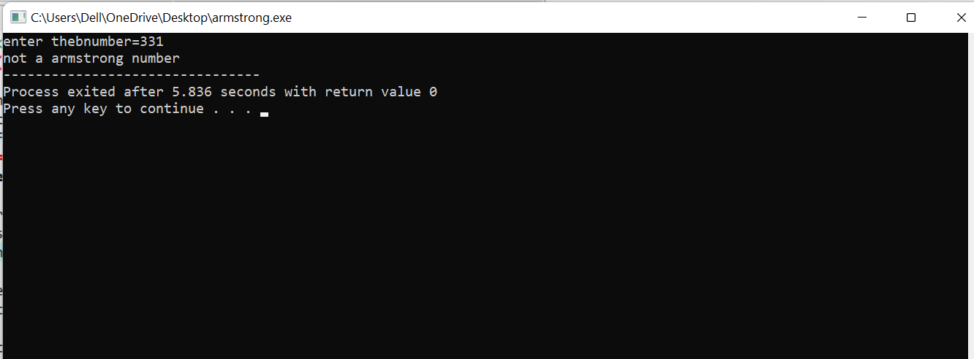

1.

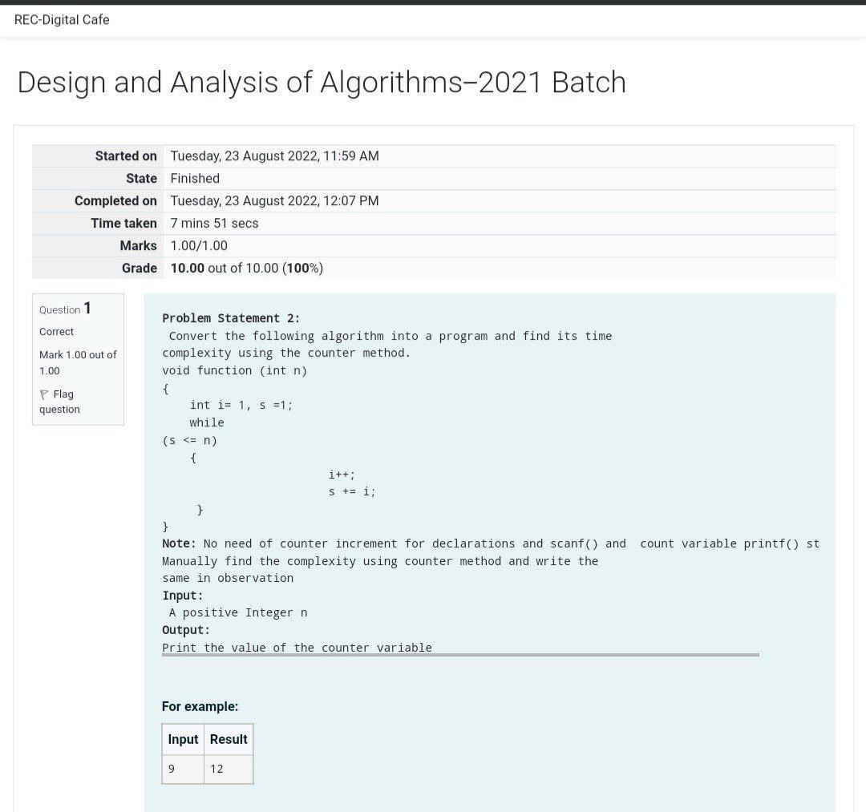

Program:-

#include<stdio.h>

void function(int min);

int main()

{

int n;

scanf("%d",&n);

function(n);

return 0;

}

void function(int n)

{

int count=0;int i=1,s=1;count++;

count++;while(s<=n)

{

count++;i++;

count++;s+=i;count++;

}

count++;

printf("%d",count);

}

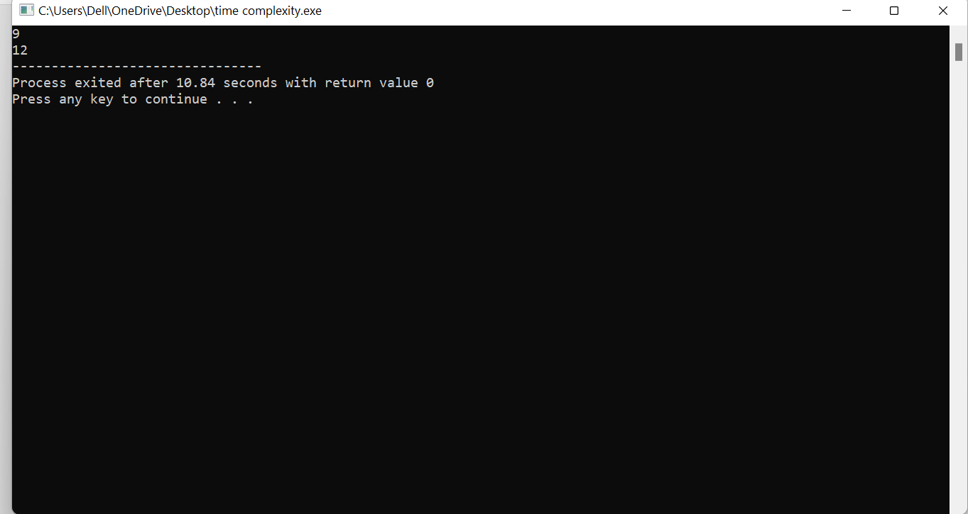

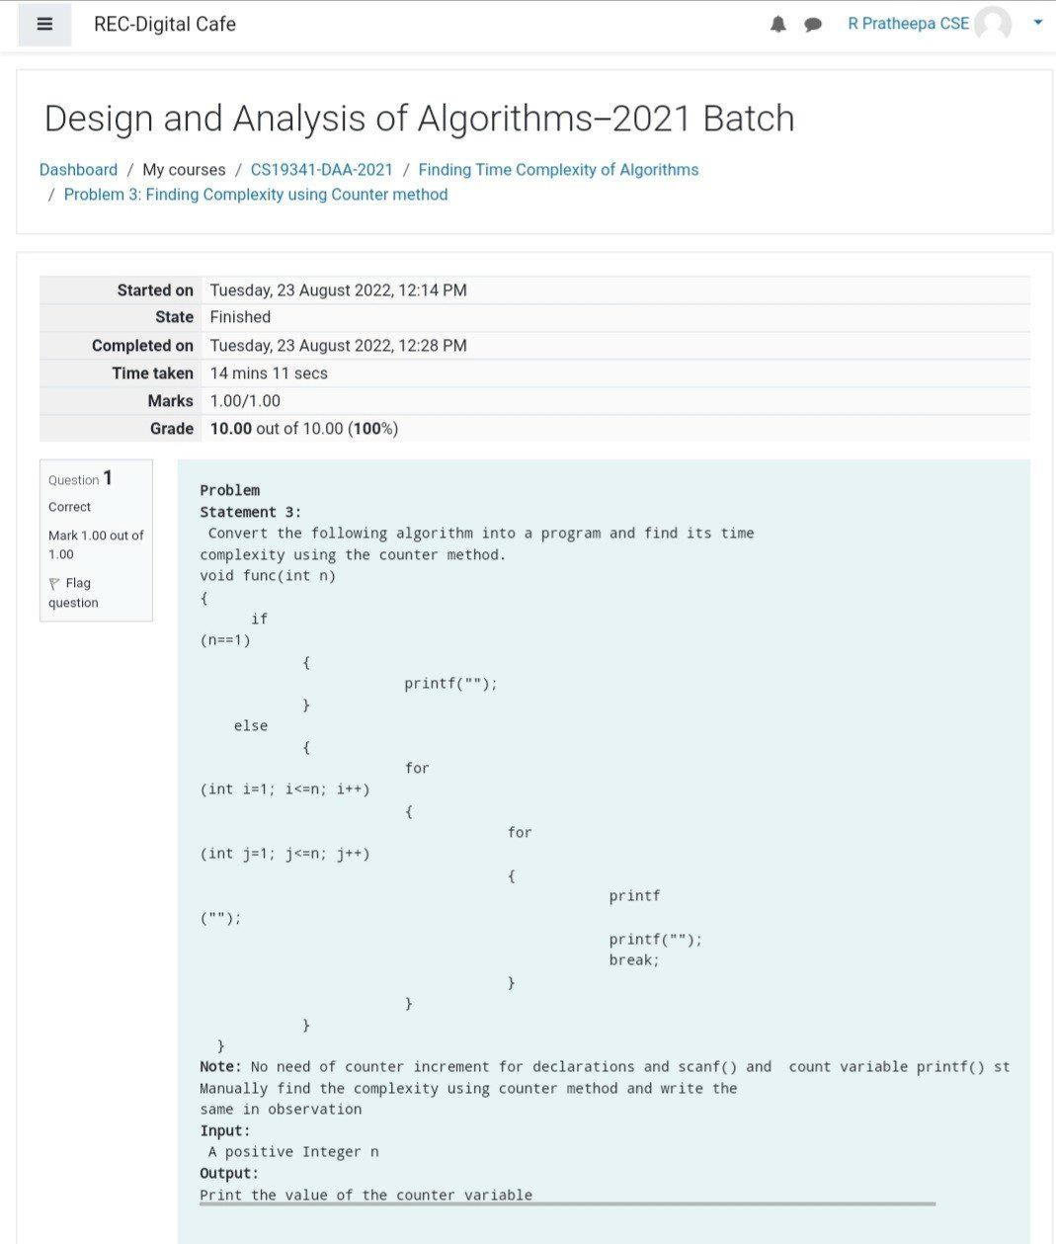

Program:-

#include<stdio.h>

void function(int n);

int main()

{

int n;

scanf("%d",&n);

function(n);

return 0;

}

void function(int n)

{

int count=0;

if(n==1)

{

count++;

count++;

}

else

{

count++;

for(int i=1;i<=n;i++)

{

count++;

for(int j=1;j<=n;j++)

{

count++;

count++;

count++;

count++;

break;

}

}

count++;

}

printf("%d",count);

}

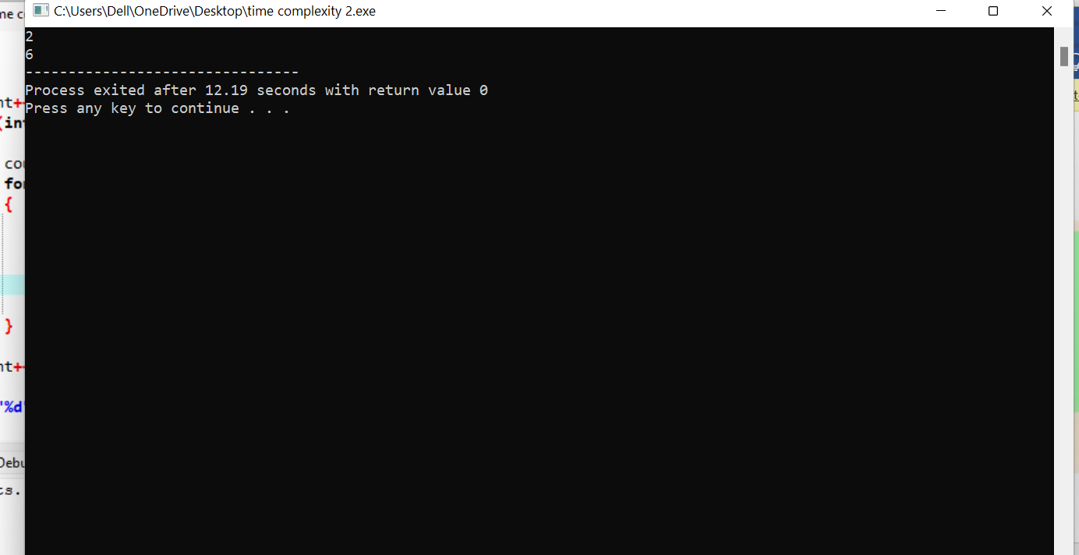

}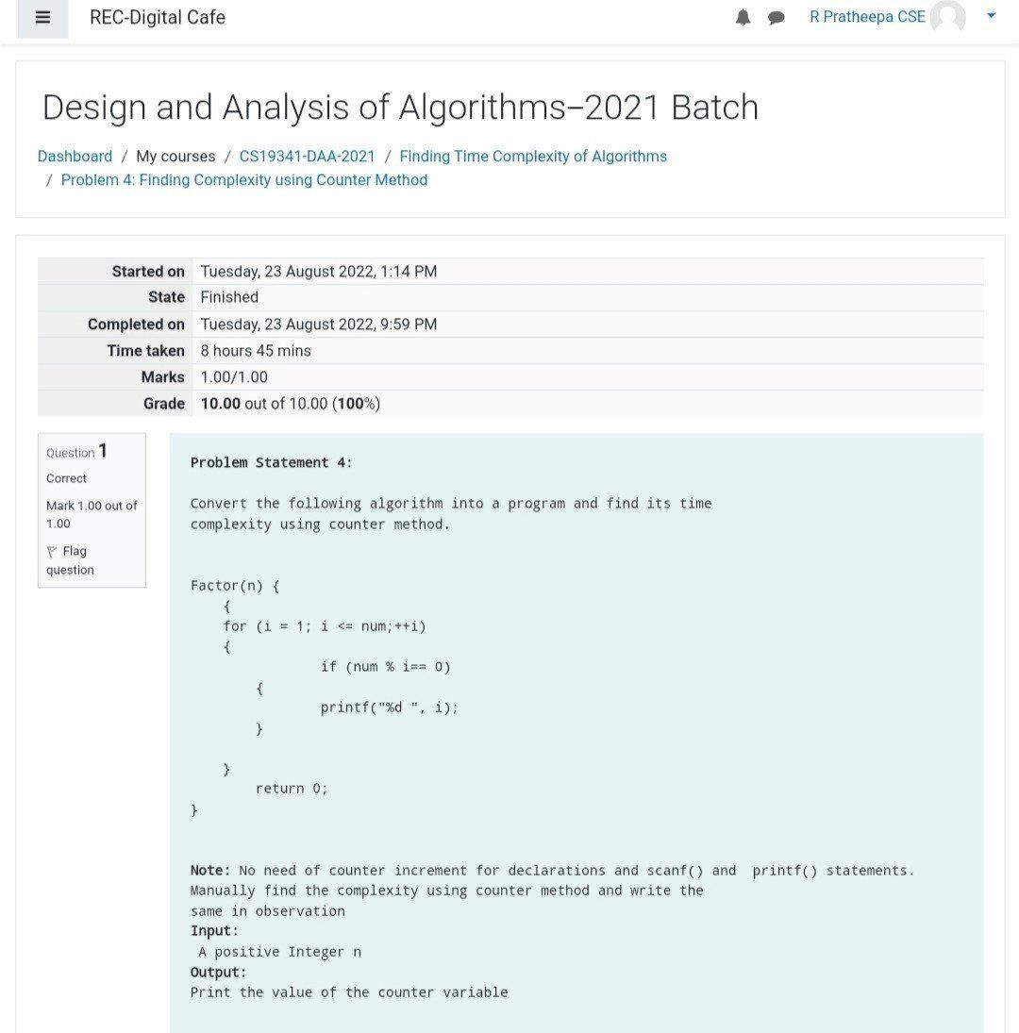

#include<stdio.h>

int factor(int n);

int count=0;

int main()

{

int n;

scanf("%d",&n);

factor(n);

printf("%d",count);

return 0;

}

int factorial(int n)

{

int i;

count++;

for(i=1;i<=n;i++)

{

count++;

if(n%i==0)

{

//print

}

count++;

}

count++;

return 0;

}

5.REVERSE NUMBER:-

#include<stdio.h>

int main()

{

int n,reverse=0,rem;

printf("enter the number:");

scanf("%d",&n);

while(n!=0)

{

rem=n%10;

reverse=reverse*10+rem;

n=n/10;

}

printf("reverse number:%d",reverse);

return 0;

}

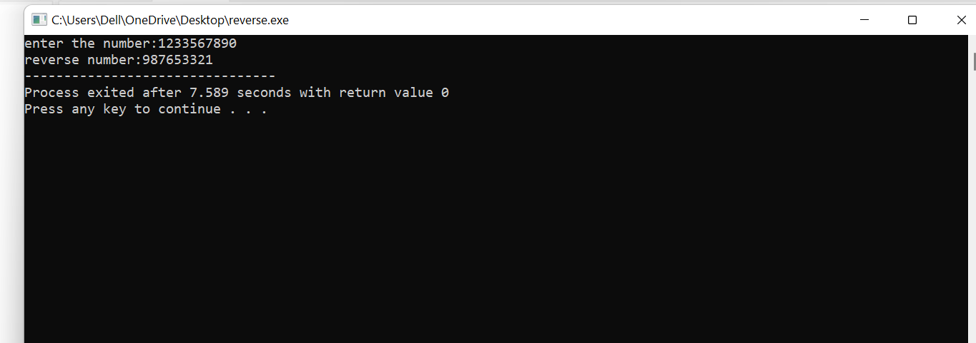

Program:-

3.

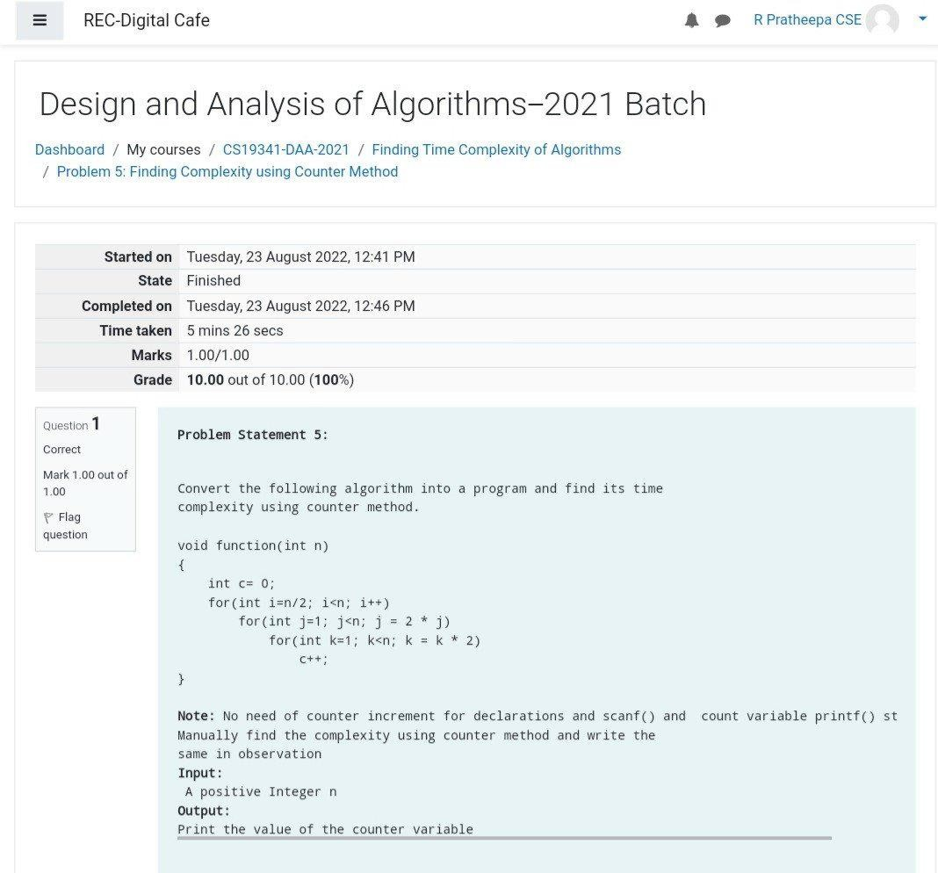

#include <stdio.h>

void function(int n);

int main()

{

int n;

scanf("%d",&n);

function(n);

return 0;

}

void function(int n)

{

int count=0;

int c=0;

count++;

for(int i=n/2;i<n;i++)

{

count++;

for(int j=1;j<n;j=2*j)

{

count++;

for(int k=1;k<n;k=k*2)

{

count++; c++;

count++;

}count++;

}count++;

}count++;

printf("%d",count);

}

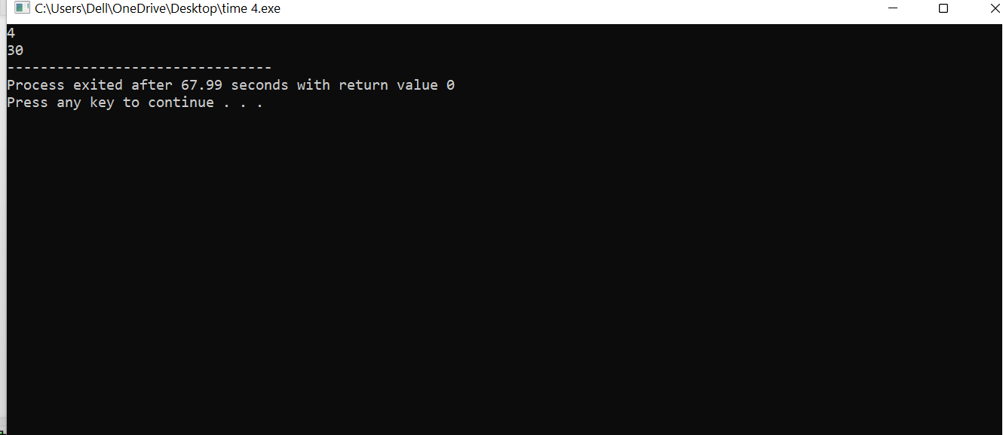

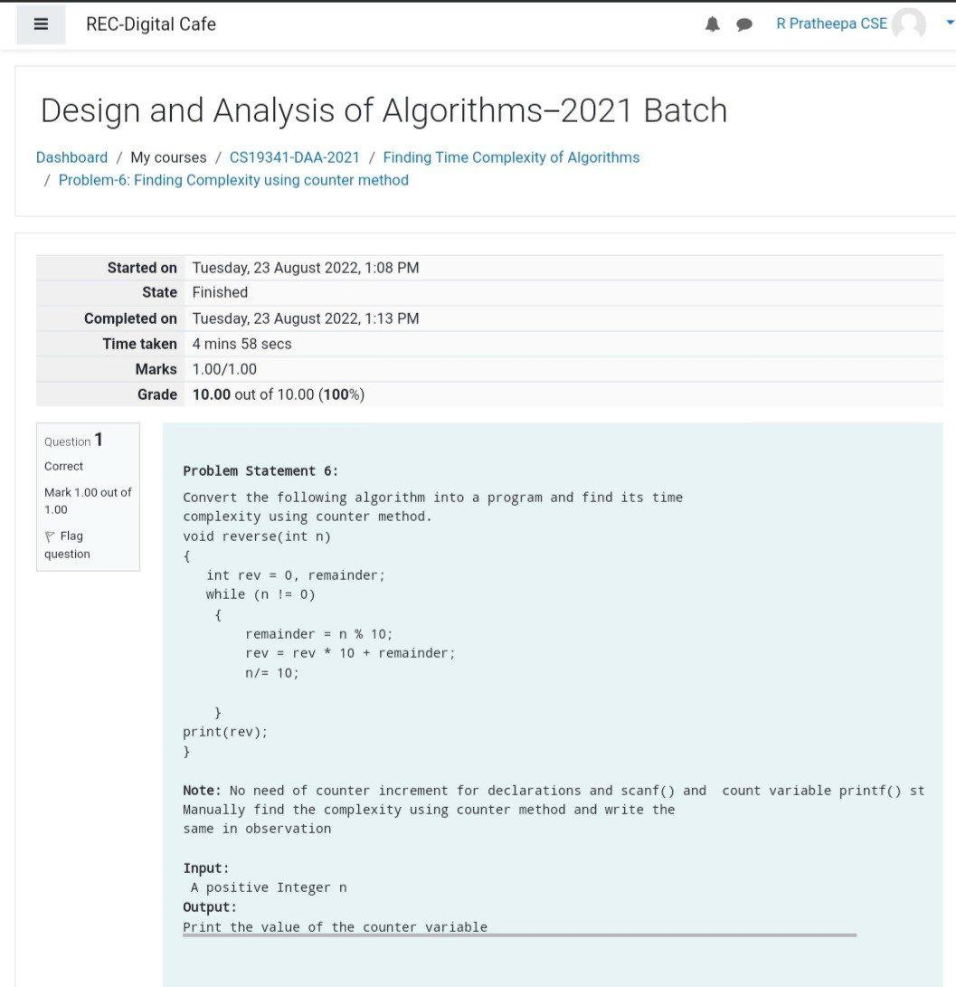

#include <stdio.h>

void reverse(int n);

int main()

{

int n;

scanf("%d",&n);

reverse(n);

return 0;

}

void reverse(int n)

{

int count=0;

int rev=0,remainder; count++;

while(n!=0)

{

count++;

remainder=n%10;

count++;

rev=rev*10+remainder;

count++;

n=n/10;

count++;

}

count++; count++;

printf("%d",count);

}

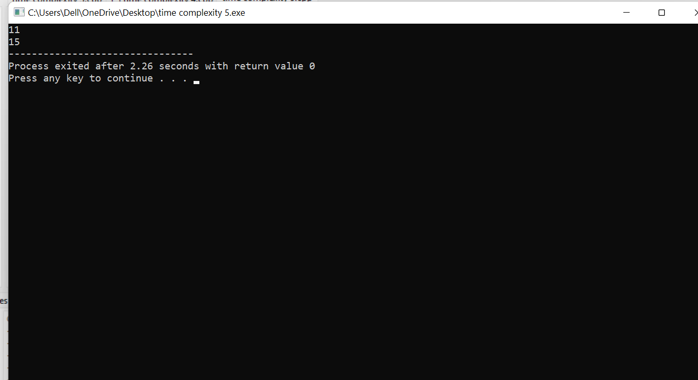

11. FACTORIAL:-

#include<stdio.h>

int factorial(int n)

{

if(n==0)

{

return 1;

}

return n*factorial(n-1);

}

int main()

{

int n,result;

printf("enter an intezer:");

scanf("%d",&n);

result=factorial(n);

printf("factorial of %d is %d\n",n,result);

return 0;

}

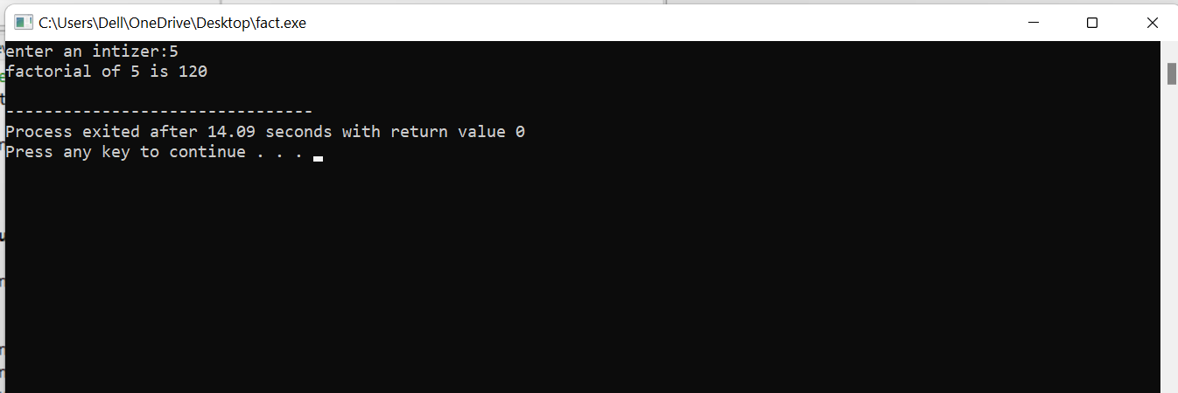

LINEAR SEARCH :-

#include<stdio.h>

int main()

{

int array[100],search,c,n;

printf("enter the element in array:");

scanf("%d",&n);

printf("enter %d intezer(s)\n",n);

for(c=0;c<n;c++)

scanf("%d",&array[c]);

printf("enter an number to search\n");

scanf("%d",&search);

for(c=0;c<n;c++)

{

if(array[c]==search)

{

printf("%d is present location %d.\n",search,c+1);

break;

}

}

if(c==n)

printf("%d isn t present in the array.\n",search);

return 0;

}

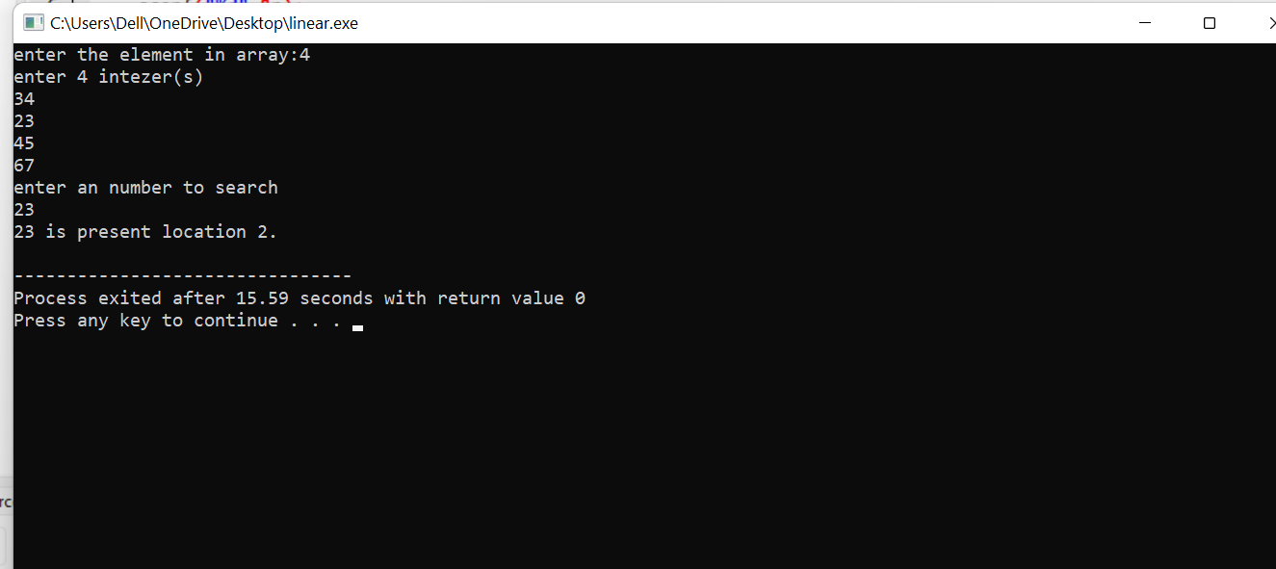

GCD

#include <stdio.h>

int main()

{

int n1, n2, i, GCD_Num;

int count=0;

printf ( " Enter any two numbers: \n ");

scanf ( "%d %d", &n1, &n2);

for( i = 1; i <= n1 && i <= n2; ++i)

{

count++;

if (n1 % i ==0 && n2 % i == 0)

GCD_Num = i;

count++;

}

count++;

printf ("gcd of two numbers %d and %d is %d ", n1, n2, GCD_Num);

printf("time complexity :%d ",count);

   return 0;

}

Out put:-

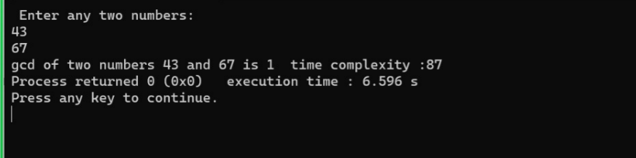

Pattern:-

#include<stdio.h>

int main()

{

int rows, coef = 1, space, i, j;

int count=0;

printf("Enter the number of rows: ");

scanf("%d", &rows);

for (i = 0; i<rows; i++)

{

count++;

for (space = 1; space <= rows - i; space++)

printf(" ");

count++;

for (j = 0; j <= i; j++)

{

count++;

if(j == 0 || i == 0){

coef = 1;

count++;

}

else

{

coef = coef * (i - j + 1) / j;

}

count++;

printf("%4d", coef);

}

printf("\n");

count++;

}

printf("%d",count);

   return 0;

}

Out put:-

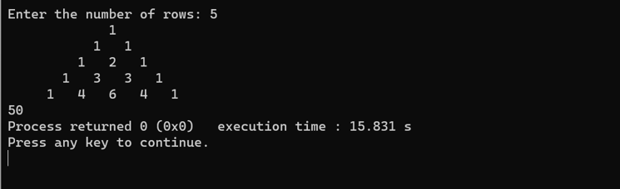

Largest element in an arrar:-

#include <stdio.h>

int main() {

int n;

int count=0;

double arr[100];

printf("Enter the number of elements (1 to 100): ");

scanf("%d", &n);

count++;

for (int i = 0; i < n; ++i) {

count++;

printf("Enter number%d: ", i + 1);

scanf("%lf", &arr[i]);

}

for (int i = 1; i < n; ++i) {

count++;

if (arr[0] < arr[i]) {

arr[0] = arr[i];

}

count++;

}

printf("Largest element = %.2lf ", arr[0]);

printf("%d",count);

  return 0;

}

OUT PUT:

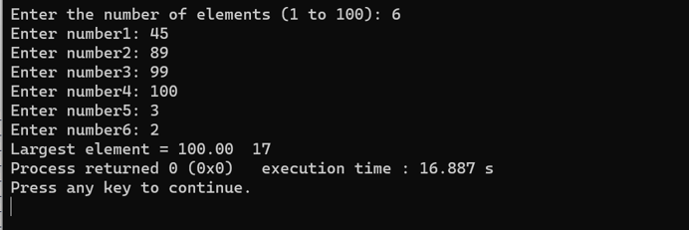

Palindrome:-

#include <stdio.h>

#include <string.h>

int main() {

char str[100];

int i, length, flag = 0;

printf("Enter a string: ");

scanf("%s", str);

length = strlen(str);

for(i=0; i < length ; i++){

if(str[i] != str[length-i-1]){

flag = 1;

break;

}

}

if (flag)

{

printf("%s is not a palindrome and reverse\n", str);

}

else

{

printf("%s is a palindrome\n", str);

}

    return 0;

}

OUT PUT :-

